Skin fold measurements and what they can tell you about your body.

As with everything I provide you, this is a “tool” to help you on your journey. Not everyone will find it helpful, but some will. This is another way to measure your progress, while hopefully moving your focus of progress away from solely being the “scales”.

This is an optional but instrumental step that can help measure the progress of your metabolism.

If you are new to skin fold measurements, you will first need to get past any reservations you have about grabbing your skin and measuring the fat that lies beneath. Because you are new, you will also have a little more variability in your results, but over time you will become more consistent with your results. There is great value in having an at home test that accurately measures your progress as you make dietary and lifestyle changes.
You might be surprised to know.
- 95% of women think they care carrying their fat around their stomachs. Whatever the reason for this…the fat storage is only higher in a woman’s hip/abdomen about 20% of the time. Excess body fat is usually on the back, where muscles are rarely engaged. Or its on the arms, perhaps due to a sluggish thyroid or lack of strength and resistance training.
- Most teenage and young men carry excess body fat on their backs. I think this is the result of a hunched posture and not engaging the muscle groups of the back regularly or correctly. Again, this can be corrected with a well-designed strength and resistance training program, that strengthens the “backside” of the core.
- When men hit their forties, they are most likely to store extra fat on their hips and back. I believe this is due to a lack of exercise and drop in testosterone (which happens due to aging and a lack of strength training).
If you set a goal of fat loss, its wise to use calipers.
People who experience weight loss with fad diets (not mine ), stimulants, or during a stressful time in their life, lose a significant amount of muscle and connective tissue. To add insult to injury here, when the weight is re-gained, even more fat and less muscle is put back on then before. And I know you do not want that, right?!
So again, using “only” the scales can be misleading. Therefore, using other metrics of measurement is important.
Remember; A pound of fat weighs the same as the stuff you do not want to lose – muscle, bone, and connective tissue.
Calipers will show you what counts and will help you track your progress toward fat loss.

*A measuring tape works a long the same lines too.

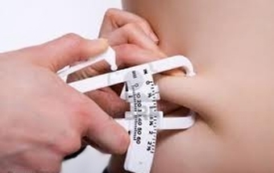
What are skin fold calipers and where do I get one?
Skin-fold calipers are simple devices that measure the thickness of a fold of skin and the attached tissue and fat underneath. You can get a good accurate and easy to read caliper on amazon. This is the one I prefer to use; https://amzn.to/3Coriri

Skin-fold calipers are a far more accurate method of assessing your health status than BMI. BMI is a simple calculation “total” weight, that includes your bones, muscle, connective tissue, brain, blood, hair, nails, etc. compared to your height. BMI reflects your total body mass or gravitational force upon your body on the earth.
And a scale does not discern between the tissues either.
PS, your brain alone weighs approximately 3 lbs and your blood is about 7% of your body weight.

Here is a good video on how to use skin-fold calipers.
https://www.youtube.com/watch?v=t50tKhMIFQ4

A skin-fold caliper is a device that measure the thickness of a fold of skin in millimeters, with its underlying layer of fat. Research has shown that the thickness of this fold, at certain key locations on your body, is representative of the total amount of fat on your body.

Where to measure.
Men and women get an accurate measurement of body fat by measuring four total points. Points should always be done on the same side of the body.
The four points are:
- Triceps – midway down the back of your upper arm
- Biceps – midway down the front of your arm
- Back – under the shoulder blade, at a 35 to 45 degree down-ward angle
- Hip – slightly forward of the top of the “hip bone” or iliac crest

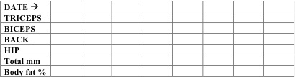

How to interpret your results.

Your healthy well conditioned goal is to have
Hips = Triceps = Back

In millimeters your body should have about the same amount of fat under the skin at the triceps, back and hip area.

This means that your body is not carrying excessive fat in one location. Having an evenly distributed amount of body fat in these areas is a mark of a balanced metabolism.

If you have found that you have higher insulin or insulin issues, you probably have a higher skin fold measurement at your hip. Post menopausal women that avoid upper body exercise will generally have their highest number at their triceps.

Your hips measurement reflects your dietary trends. If body fat goes up in the hip, a shape commonly referred to as an apple shape, it is usually due to excess carbohydrates. Conversely if your body fat on the hip drops, this is due to a reduction in stored carbohydrates. Insulin resistance and high insulin create a disproportionate increase in body fat at the hip. Body fat on the hip and torso reflects fat that has or may have also deposited around your liver and heart area. Heart disease risk is strongly associated with excessive fat on the hip/torso region. Along with heart attack, stroke, dementia and some cancers.

If the hip: triceps ratio is 2:1 in women, I suspect type 2 diabetes or at least insulin resistance. They same type 2 diabetes suspicion arises when the hip: triceps ratio is 3:1 in men.

Your triceps reflect the tone of your extremities. Your legs mirror the same pattern as your arms, so do not need to be tested separately. If your triceps are the highest number, it may be because you are “out of shape”. But people with hypothyroid can show the same imbalance (this doesn’t mean we completely blame it on the thyroid as people like to do). This body shape is more commonly know as the pear shape. Generally, fitness habits need to change to address this imbalance. Results are usually quick; if your body can make fat, it has the ability to make muscle too.

Increase resistance training, get your heart rate up and if needs, focus on thyroid supporting nutrients. If this problem persists, it is wise to get your thyroid checked.

Your back shows a combination of dietary carb balance and conditioning. In agriculture, to get a higher fat content on the back straps of livestock, you limit the animal’s movement and feed it a high grain diet.

Prior to any exercise, make sure you have been properly instructed to keep your core body posture upright and your shoulder blades engaged. You need to move towards core fitness and lower carbs. Do the opposite to what is done with livestock.

Your biceps also reflect conditioned muscle tone in the extremities. With a normal hormonal balance and muscle tone, your biceps should measure about half of your triceps. If the biceps are carrying higher proportional body fat, specific resistance and dynamic exercises of the extremities are needed to encourage blood flow and muscle growth to the area.

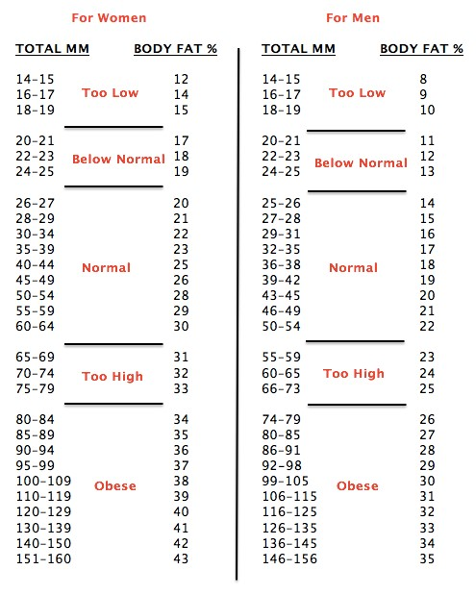

The location of your fat should help you decide whether to emphasize diet or exercise. Measure every 4 weeks.
- If your skin-fold measurement on your hip gets smaller, it is due to an improvement in your diet.
- If your skin-fold measurement gets smaller in the triceps, it is because of conditioning and better exercise. You are in better shape, as they say.
- If your skin-fold measurements show proportional loss in all areas, you are doing a great job improving both diet and exercise habits.

You can also add the 4 numbers together to get your total body fat percentage.



