DETOXIFICATION IN YOUR BODY
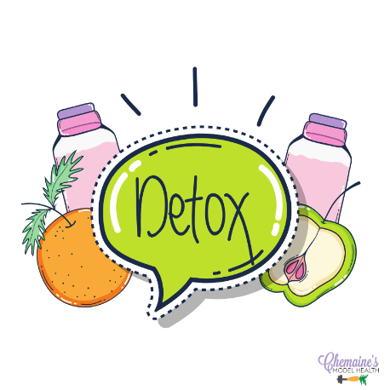
This post is an easy-to-understand explanation of the three phases of detoxification (detox).

Most of your body’s toxic waste goes through three phases in your liver-gut and liver-kidney detox systems. And is excreted through your bowel, urine, sweat and breath.

Phase 1
This is your first line of defense against toxins and uses a group of enzymes known as the cytochrome P450 family. These enzymes protect your cells from damage by:
- Converting volatile toxins into smaller substances meant for further detox
- Making toxins water-soluble to enter Phase 2
Phase 1 is activated by many external toxins. Examples include caffeine, alcohol, dioxin, paint fumes, steroids, pesticides, sleeping pills, contraceptive pills, and cortisone. It is also activated in a favorable way by:
- Herbs: milk thistle, sassafras, caraway, and dill
- Citrus: tangerines and oranges (grapefruit shuts down Phase 1)
- Vitamin C rich foods like strawberries and bell peppers
- Crucifer veggies (also called Brassica): Brussel sprouts, broccoli, cabbage, cauliflower, collard greens, kale, and turnips
- Vitamins: C and most of the Bs
- Lipotropins: compounds that break down fat in metabolism (cysteine, methionine, choline, and inositol)
- Minerals: magnesium and iron

Phase 1 causes oxidation and free radicals
Phase 1 is all about the oxidation of harmful toxins in order to break them down into less harmful metabolites. This is necessary, and it does result in free radicals which can do lots of harm (even to your DNA) if you don’t keep them moving through your detox pathways and OUT of your body!
It’s a good idea to increase antioxidants as protection. Some of the Phase 1 activators ARE antioxidants (like vitamin C and silymarin in milk thistle). However, it’s good to add more, especially polyphenols and flavonoids. If you eat 5-7 servings per day of a wide variety of fruits and vegetables every day you are probably covered.
Supplemental additions include things like resveratrol, coQ10, vitamins A, C, and E, minerals selenium, copper, zinc, and manganese. However, if you take large supplemental doses of these antioxidants every single day, you run the risk of shutting down the production of your own master antioxidant, and hands down THE most important one: glutathione.

Phase 2
Phase 2 is all about conjugation, which uses 6 different pathways to take water-soluble Phase 1 metabolites OUT of your body through your bile, urine, and stool (poop).
For the science types, these are glucuronidation, acetylation, esterification, amino acid conjugation, sulfation, and glutathione conjugation
Phase 2 absolutely requires:
- Sulfur: from crucifer veggies, garlic, onions, meat, and egg yolks
- Amino acids: glycine, cysteine (NAC or n-acetyl cysteine), taurine, and methionine (from meat)
- Molybdenum: meat, especially red meat, and salmon
- Glutathione: which is made from the above amino acids, NAC and Vitamin Other nutrients and foods that help Phase 2 are flavonoids (found in fruits, vegetables, and many herbs), ellagic acid in red grape skin, garlic, rosemary, soy, and cabbage.

When Phase 2 goes awry
The catch is that Phase 2 liver detox is often sluggish, probably because of the lack of intake of the above nutrients in sufficient quantities. You really do not want this, because the metabolites of Phase 1 are quite dangerous and need to be excreted asap!
So, you may activate Phase 1 simply by your morning coffee and your evening tea, yet if you have a sluggish Phase 2, you could suffer the results of these “toxins” hours later. This may explain your insomnia, brain fog, or hot flashes, for example.
There is growing scientific evidence suggesting that certain diseases are the direct result of damage to the body from poor Phase 2 detoxification. This includes cancer, Parkinson’s, fibromyalgia, chronic fatigue, lupus and immune dysfunction.

Phase 3
This is about transportation. It mainly refers to the transport of Phase 2 conjugates either: to your kidneys for further filtration and then out of your body via your bladder and urine OR out with your bile into your small intestine, and down through your GI tract for elimination via stool.
Phase 3 requires:
- Adequate hydration for the kidney-urine elimination
- Proper function of your GI system so that you can poop well! This means pooping daily, without constipation, sluggishness, loose stools, or diarrhea. You want your poop to score a #3 or 4 on this Bristol chart:

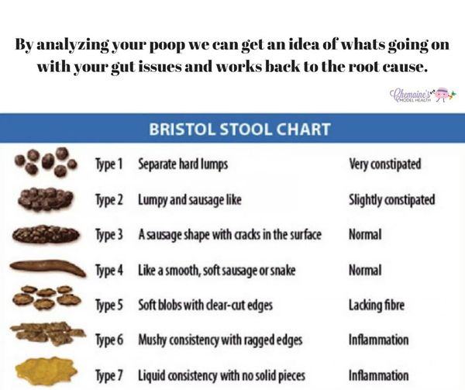

Toxins
This is worth understanding. The words toxin and toxic get thrown around a lot, but what do they really mean? What are you trying to get rid of? Generally, the word toxic means poisonous or harmful. Toxins come from inside and outside your body.

Internal toxins
In your body, these include:
- The by-product of microbes that live in your gut
- Biotoxins like mold
- Damage from chronic infections like Epstein Barr virus or Lyme spirochetes
- Chronic inflammation
- Chronic stress chemistry
- By-products of your own cellular metabolism that don’t get efficiently processed and eliminated (like hormones or harmful metabolites of Phase 1 liver detox)
- Dead or damaged cells
If you do not have a perfectly functioning metabolism, have extra belly fat, have chronic inflammation or infections, have poor liver function, and issues with your gut microbiome, it’s likely you have some endotoxins to clean out.

External toxins
Most of these toxins come from your local pharmacy and liquor store! In other words, things you voluntarily ingest. External toxins also include pesticides, pollution, and metals like mercury and lead. Environmental toxins can get packed away in your body tissues, including fat cells.
Your body is constantly processing and eliminating toxins daily. However, it can be difficult to keep up with the demand. That is why it’s a great idea to do a focused detox on a regular basis – once, twice, or four times a year. How do you go about it?

First of all, get elimination in order
If you don’t produce at least one #3-4 Bristol stool per day, you have a problem.
Why? You may be creating volatile, reactive, semi-processed chemicals (and hormones) that you are able to get rid of properly! This means these toxins, hormone, lipopolysaccharides (poison) and reactive oxygen species (ROS or free radicals) that will cause inflammation and cellular damage are being reabsorbed and recirculated in your body. Also, these toxins from your gut, when reabsorbed, cause widespread inflammation and pain – sometimes severe pain.
So, if you’re not a good pooper, then check out dysbiosis and other potential root causes, and address it first (see the podcasts and posts I have done). You may also need to investigate food intolerance. But you can still support your detox pathways daily.

Lighten your load
This means reduce your exposure to things that cause an added burden for your liver to process. You can do it these ways:
- Don’t take unnecessary medications (NSAIDs and antibiotics are poison)
- Avoid foods void of good nutrition and that are also higher in toxins – processed foods, alcohol, toxic polyunsaturated fats and excess sugar
- Fast OR eat clean daily
- Only eat and drink out of glass, ceramic or stainless steel
- Drink lots of the cleanest water you can get your hands on
- Consume essential minerals daily but not “table salt” or “added salt” in processed foods
- Lighten the load on your mind as well –– Self care! Read, walk in nature, laugh daily, go on a retreat, a staycation, or just put up drama boundaries and lie low

Activate detox pathways
You can design your own combination of foods and supplements to activate Phase 1 and 2 of liver detox. Or you can use formulas that already exist, as high integrity supplement and herb producers/brands have some good detox formulas and support tools. Also, fasting will activate detox pathways.
Don’t forget Phase 2! This is the phase that tends to be more sluggish and you do not want to activate Phase 1 without supporting Phase 2.
Choose Phase 1 and 2 activators from above. It’s essential to get all essential amino acids and minerals in during a detox protocol. Your liver needs all of them, in sufficient amounts.

What?
- You need a significant amount of amino acids for your liver to do its job. Amino acids come from breaking down your body (which you don’t need), or from ingested protein (preferable!).
- You need fiber to bind with toxins and move them out through your colon. Fiber is in whole vegetables and low glycemic fruits – the skins.
- Healthy fats are essential to stabilize your blood sugar.
- Foods stimulate bile flow, and bile binds with toxins and moves them out – think of our bitter, sour, astringent and tart foods. Check out the posts and blogs I did on choleretics and cholagogues.

How?
- Eat clean as much as possible: Organic to avoid pesticides, and whole foods to avoid additives.
- Include protein: Half your ideal body weight in pounds (at least) – this is the number of protein grams to target, divided between meals.
- Add anti-inflammatory fats: Omega-3 fats from clean wild caught seafood, krill, cod liver oil, and grass-fed meats.
- Eat lots of organic greens and cruciferous vegetables each day for the nutrients and fiber.
- Hydrate: aim for 1 ounce of fluid per 1 lb of body weight. More if you exercise, sweat a lot, take medication or there is a heatwave.
- Add Phase 1 and 2 detox activators: such as selections from above. The good news is that glutathione is key to activate phase 2 – think vitamin C.
- Add fiber: to bind with toxins if you need. Fiber also feeds beneficial gut bacteria and helps make good Bristol #3 and 4 stools.
- Consider binders if you have gut dysbiosis or toxic overload, to bind endotoxins. I like activated charcoal, zeolite and bentonite clay. Also cilantro, spirulina and chlorella.

Best veggies
The vegetables that provide nutrients for Phase 1 and 2 detox pathways include:
- Crucifers (also called Brassica): Brussel sprouts, broccoli, cabbage, cauliflower, collard greens, kale, and turnips.
- Leafy greens: Parsley, kale, watercress, chard, cilantro, beet greens, escarole, dandelion, and mustard greens.
- Citrus: oranges, lemons and limes (avoid grapefruit and grapefruit juice, which slow Phase 1)
- Sulfur-rich foods: crucifers, garlic, onions, leeks, scallions, shallots, cheese, yogurt, meat and seafood (and eggs).
- Liver and gallbladder supportive: Artichoke, asparagus, beets, celery, dandelion greens, arugula greens, dandelion-root tea, mothers’ milk or milk thistle tea, and burdock root tea.

Lifestyle factors
While doing the above is awesome, we still need to support the flow of blood and lymph through our body so that we can constantly be flushing our detoxification pathways and then excreting. If you don’t encourage this movement of fluids through the body, then they will build up and the toxins will deposit/lodge in joints, tissues, cell membranes and fat cells (even in blood, which we do not want).
- Move, move, move! Any movement is great, and sweating has an added bonus, as 1% of sweat is composed of toxic waste. Movement should be done several times a day. Exercise and movement, gets the body pumping fluids – fascia, muscles, heart and lungs.
- Rebounding is one of the best forms of exercise for moving blood and lymph fluids.
- Inversion moves, this moves trapped toxins and lymphatic fluid from our feet and lower legs, back to our excretory organs.
- Body brush and foam roll, this will help liberate and move fluids and toxins out of the fat cells and fascia.
- Sauna is one of the best things you can do also for detoxification, just make sure you re-mineralize and hydrate during and after. And no a hot tub does not count, it actually does the opposite.
- Hot as you can tolerate them Epsom salt baths a few times a week helps to open your pores and pull toxins out, while lowering cortisol. Remember do not stay in the bath longer than 15 minutes – at this stage the body will stary to reabsorb toxins.
- Sleep! Sleep is top for detoxification as this is where our healing and regeneration happens, and where toxins are moved to our excretory organs. This is where inflammation is reduced, and inflammatory toxins are released to be excreted. Don’t forget your evening tea!


