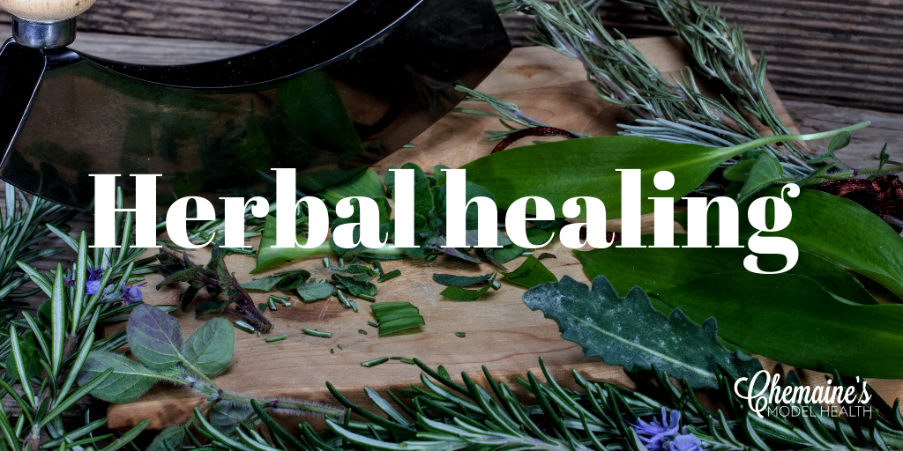

Herbs and spices have been used in medicinal fashion since the beginning of time. The Chinese, Middle Eastern’ s, Greeks and Romans hold some of the best kept recipes to using food as medicine and have done so for thousands of years. A concept which is again, getting attention by those looking to optimize their health --- giving the body what it needs to heal.
Hippocrates, the Greek physician and ‘father of medicine’, advocated the use of a few simple herbs, along with fresh air, rest and good nutrition to aid the body in strengthening its own ‘life force’ to eliminate any health problem.
There are many ways to use herbs to provide a wide variety of treatments. They can be taken as teas, wines, tonics, syrups, added to dishes or used topically. The below list is some of the most common herbs and my favorites (in no particular order), that can be easily integrated into your nutrition each day, in small amounts, to help provide your immune system and cells with a broader spectrum of vitamins, minerals and other essential nutrients. Sprinkle them onto your meals and reap the benefits xo

- Rosemary – has been used as a natural migraine treatment for years. It has also been shown to be very effective at regulating blood pressure and managing hot flushes. Rosemary can be used in cooking to prevent carcinogen build up on meats/foods during grilling, BBQing and frying.
- Milk thistle - supports the function of the liver and promotes bile flow. Excellent herb to promote bile flow when breastfeeding. Stimulates appetite and reduces high cholesterol levels.
- Marshmallow – the mucilage in marshmallow has been shown to support digestive health, particularly with constipation. It soothes and protects the bodies tissues – this herb is a very effective anti inflammatory, especially in the urinary, respiratory and digestive tract.
- Astragalus – can help with water retention and reduce blood pressure. Astragalus is a stimulant (supportive) for the immune system and can be improve vitality. Add this into your winter protocol to help lessen the symptoms of cold/flu.
- Marigold (Calendula) – is a great antiseptic, antibacterial and anti-viral herb. It has been shown to help with varicose veins and menstrual symptoms. Can help with ulcerative conditions and be taken as a liver tonic.
- Camomile – know as the ‘mother of the gut’ because it acts as a muscle relaxant in the gut. Can help with nausea, indigestion and works as a sedative for the central nervous system which helps you get into a more rest and digest state.
- Black Cohosh – traditionally used for easing PMS symptoms, it is thought to balance estrogen by stabilizing it. It does this by reducing progesterone and promoting estrogen. It has also been shown to help with lowering blood pressure, inflammation and reducing tension in the body.
- Hawthorn – acts on the cardiovascular system, regulating the heartbeat, relaxing the arteries and normalizing blood pressure. Used in angina and coronary artery disease. Hawthorn can also be used to aid in the digestion of meats and greasy foods.
- Ginseng – an amazing adaptogen that can be used to support the adrenals and balance cortisol. Benefits the heart, helps with palpitations associated with anxiety, insomnia and after times of trauma or stress.
- Meadowsweet - known for its anti-inflammatory and painkiller abilities. Which are believed to help heal the gut where there is inflammation. Meadowsweet tea is also used to support the liver and gallbladder as it is said to improve the production of bile flow. It has a marked diuretic effect that helps with the excretion of urea and uric acid – thus aids in treating Gout and Kidney stones. * Should not be taken if you have an allergy to Aspirin.
- Licorice - used to treat nausea, bloating, vomiting, indigestion, stomach ulcers and constipation. As well as mild asthma, dry cough and other chest complaints. Licorice root mimics the actions of cortisol and tells the adrenals to calm down. * Too much can cause blood pressure issues.
- Goldenseal - part of the berberine family, has antibacterial properties and is used in the treatments of eye, nose, mouth and throat infections. Alleviates heavy menstrual bleeding and vaginal infection.
- St. Johns Wort – primarily works in the nervous system and brain, acting as an antidepressant and supports the brain in times of mental and emotional stress. Can help with viral complaints such as Shingles, Herpes, HIV and AIDS.
- Lavender – has a calming and relaxing effect on the body. Helps with --- indigestion, gas, bloating, headaches, depression, insomnia, painful joints and nerve pain.
- Lemon balm – helps soothe and calm the central nervous system and has a relaxing effect on the body. It can be used in states of excitability, palpitations, depression and headaches. Lemon balm can be used to ease symptoms on menopause, including hot flashes and anxiety. May also help with irregular or painful periods.
- Peppermint – awesome antiseptic effect, aids the digestive system, including IBS attacks. It contains a diaphoretic compound, a compound that induces sweat, so can be used to cool down a fever resulting from cold or flu.
- Sage – its antiseptic properties makes it very effective to be used as a gargle or mouthwash. Can improve circulation, digestion and in the reproductive system, can be used to bring on delayed period. In menopause, it can be used to relieve sweats and balance hormonal changes. Do not take during pregnancy.
- Elderflower or elderberry – has an anti-inflammatory action and mostly benefits the respiratory system. It has a diaphoretic effect that encourages the loss of toxins through sweating, which can be useful in colds and flu where it can minimize the symptoms and even the length of the illness. Can also be used for earaches, chilblains, wounds and arthritis.
- Chasteberry – used to help the body regulate the ratios of sex hormones estrogen and progesterone. It is also very effective at detoxifying the bad estrogen (16a-hydroxyestrone) along with a good nutrition and lifestyle protocol. This herb is invaluable at treating many issues associated with PMS and estrogen dominance like – migraines, irregular heavy, painful and clotty periods and infertility. Has been shown to improve acne in some also.
- Crampbark – acts as a muscle relaxant. Relieves cramps during period and during and IBS attack. Crampbark also helps reduce blood pressure and relaxes the airways in asthmatics. *Do not take if pregnant or have low blood pressure.
- Ginger – probably one of the best anti-inflammatories on the planet. Its oils act as a protectant in the liver and antiseptic and anti-inflammatory in the stomach. Ginger is also thought to reduce cholesterol levels, while at the same time improving circulation. Ginger can be used to minimize nausea, including during pregnancy. * Do not use with stomach ulcers.
- Dandelion – leaves contain a high amount of potassium which help it act as a diuretic. While the root is used in supporting the liver and its health. Both leaf and root act as a tonic to the gallbladder. Effective in supporting the detox pathways in removal of toxins from the body.
- Thyme – primarily used as a remedy fort he respiratory system. It has antiseptic properties and can help with the elimination of worms or parasites. Thyme has been shown to aid with asthmas, bronchitis, hay fever, sore throats, coughs, arthritic complaints, cold joins, aches and pains and urinary tract infections. * Do not use during pregnancy.
- Turmeric – is an effective anti-inflammatory for the gut and body. Antioxidants found in Turmeric, including curcumin, may help to ward off cancer causing free radicals and protect the brain from Alzheimer’s. Turmeric as a painkiller can be 4 times stronger than ibuprofen.
- Slippery elm – soothing herb for digestive complaints including constipation. Can also be used externally to treat boils and abscesses.
- Rosehips – have been shown to be very effective at treating arthritic pains.
- Oregano – regular use of oregano can be a great way to clear out unwanted bad bacteria and fungi. Also, can be used as an insect repellant.
- Basil – is a great source of vitamin K and can help prevent blood clotting. Basil is also effective at fighting bacterial and fungal overgrowths. Classed as an anti-inflammatory herb.
- Cinnamon – helps the body metabolise sugar and resensitize to insulin. Helps to relieve nausea, vomiting, diarrhea and headaches.
- Cloves – stimulate the digestive system. Cloves are powerful antiseptics and can be used on gums/teeth for a toothache because of their mild anesthetic properties.
- Black pepper - can be added to foods to improve the assimilation of nutrients. * Be careful when using black pepper with medications.
- Saw palmetto – can be used for the side effects of too much DHT in the body, like excess hair growth on the face and chest in women. Can help improve low estrogen levels in women and improve issues with alopecia and hair loss. Saw palmetto has been shown to be effective in treating issue with the prostate in men.
- Skullcap – acts as a sedative which helps calm the body both mentally and physically. Because of this it can be an effective sleep aid. Shown to be anti-inflammatory, anti-allergenic and helps alleviate period or ovarian pain.
- Birch – has been shown to reduce inflammation and regenerate tissues in the kidney tissues. Birch helps prevent the formation of stones in the kidneys, bladder and gallbladder by helping to eliminate calcium oxalate microcrystals. Can be used to flush out the urinary tract as a treatment for infections, as it increases urination which eliminates pathogens.
- Fennel – stimulates digestion and has an effective action towards eliminating intestinal gases that cause bloating and farting.
- Eucalyptus – its leaves have expectorant, mucolytic, antispasmodic, antiseptic, and slightly antipyretic (reduces fever) properties. Mainly acts on the respiratory tract and supports keeping the airways open. Topically it can be used to treat muscle or joint pain and to heal wounds.

PS; this is the first draft so I will be updating in time with more herbs, spices, allies you can add to you kitchen cabinet to support your health journey xo

